**BEST PRACTICES OF ACTIVE LEARNING FOLLOWED BY THE SOCIAL SCIENCE DEPARTMENT AT THE ASHOK LEYLAND SCHOOL**

**Theme:**

Use of innovative tools such as storytelling, theatre, mind mapping etc.for pedagogy.

**Prepared by**

**Mr. Vivin David Varghese, BA( JPEng), MSW(HR), D.Eld)**

**vivindavid@thealschool.org**

**Mrs. Uma Srinivasan  
Principal.  
The Ashok Leyland School  
E-1 Sipcot Industrial Complex,Phase II, Hosur-635130, Tamil Nadu.**

|  |  |  |  |  |
| --- | --- | --- | --- | --- |
| **TABLE OF CONTENTS** | | | | |
| 1 | INTRODUCTION | | | 03 |
| 2 | CASE STUDY/ PRESENTATION | | | 04 |
|  |  | | IDENTIFICATION OF THE PROBLEM | 04 |
|  |  | | ANALYSIS OF THE PROBLEM | 04 |
|  |  | | OBJECTIVES | 04 |
|  |  | | PLANNING DONE | 04 |
|  |  | | SUCCESS CRITERIA & POSSIBLE ALTERNATIVE DECIDED | 05 |
|  |  | | IMPLEMENTATION | 05 |
|  |  | | CHALLENGES FACED IN IMPLEMENTATION | 06 |
|  |  | | RESOURCES INVOLVED | 07 |
| 3 | EVIDENCE OF OTHER STRATEGIES | | | 8-11 |
| 4 | BENEFICIARY SATISFACTION | | | 11 |
| 5 | CONCLUSION | | | 12 |
| 6 | KEYWORDS FOR SEARCHING ON IT PLATFORM | | | 13 |
| 7 | APPENDICIES | | | 13 |
| 8 | CERTIFICATE OF ORGINALITY | | |  |
|  | A | BY SCHOOL PRINCIPAL | | 14 |
|  | B | BY AUTHOR | | 15 |
| 9 | NOC | | | 16 |

**ABSTRACT**

This study is done to promote Active Learning Participation in Social Studies. As times have changed, the frontal method of teaching must be done away with a more participatory approach that promotes innovation, exploration, wherein the teacher is merely a facilitator in the learning process. Through this measure I believe that social studies would become more fun to learn and students would be more engaged thus facilitating a better understanding of the concepts.

**INTRODUCTION**

Generally, Social Science is considered to be a dry subject and not liked by many. Many social science teachers had preferred the frontal method which has added to a general boredom where students tend to be highly distracted, dreaming, scribbling or lacking a great zeal to learn. Many tried and tested mechanism have been used by me in the past to create a method wherein the students would enjoy the subject which they usually termed as “Dry and vague”.

Hence , I tried to create an environment in the classroom, which acknowledged learners to be active participants in the learning process by building knowledge and understanding and me as a teacher, a mere activator or enabler in the learning process.

Through my findings I realized that Active learning fosters an understanding which students can then apply to diverse contexts and this learning process gives them the following:

* The much needed autonomy,
* Greater involvement and control over their learning and
* Giving them skills to foster lifelong learning
* Learners will be better able to revise for examinations in the sense that revision really is ‘re-vision’ of the ideas that they already understand.

**CASE PRESENTATION**

1. **IDENTIFICATION OF THE PROBLEM-**

Students found it hard to recall the previously taught concepts as the teacher preferred to teach in a frontal/ direct method.

Students would appear to be silent but later on I understood that they had been watching the teachers’ faces in a clueless manner, making no sense of what was being taught as they appeared to be lost as the classes were a mere one way communication.

Students also didn’t obtain good grades and a gradual dip was seen in the marks of many. A general discussion with the students on the reasons why they fared poorly motivated me to change my teaching methodology and make it student centric than teacher centric.

1. **ANALYSIS OF THE PROBLEM-**

The students found it hard to learn and recall as due to the frontal method a lot of rote learning took place. Thus many a times they found it hard to understand and recall the details. Moreso it didn’t build critical thinking skills.

1. **OBJECTIVES**

To promote critical thinking and better recalling of social studies through various active learning methods.

1. **PLANNING DONE-**

The teacher reworked on the teaching methodology to avoid direct teaching and focused on making the procedure students centric. Thus the first change was to rework on the lesson plans and make the plan more student friendly. Warm-up strategies were altered, keeping the child in perspective. Classes were also planned to make it more interactive; exploration of texts, games, case studies

1. **SUCCESS CRITERIA AND POSSIBLE ALTERNATIVE DECIDED**

Alternate strategies that included KWL, PMI, Debate, Role Play, Newspaper Cutting, Graffiti wall etc. were integrate to bring about the change in teaching methodology.

1. **IMPLEMENTATION**

**Newspaper Cutting-** To improve and garner more knowledge in the field of Electoral politics amongst the students, the warm-up activities in the class included a lot more use of newspapers, magazines in the classroom settings. The students read the newspapers/ magazines related to the topic and were asked to cut and paste the relevant articles in their classwork and followed by a discussion on the article. Children were also encouraged to find more information based on the same. Through the same the teacher enables the learners to build knowledge through talking, reading and writing. The teacher believed that the usage of dialogue, discussion and group work is important in connecting currents affairs to the topic, research and ultimately resulting an interest to the topic.

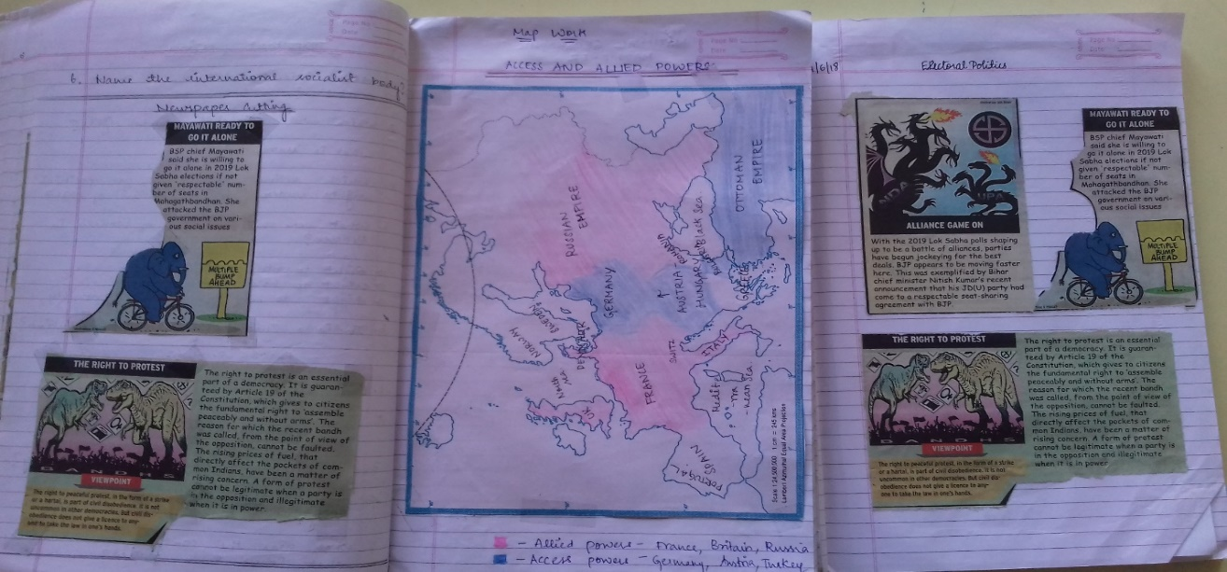

**Lesson plan for newspaper cutting** - <https://theashok-my.sharepoint.com/:w:/r/personal/leni_thealschool_org/_layouts/15/Doc.aspx?sourcedoc=%7BB4214541-5F4F-4D93-AAFF-5C2229983FF1%7D&file=IX_Unit%20Plan_SS_Electoral%20Politics.docx&action=default&mobileredirect=true>

**Graffiti wall –** This technique is used in our department both as a Warm-up as well as a recapitulation method wherein the students are asked to write the key points of the topic on the board. This activity engages the students who are then forced to critically think,

Organize concepts. This also helps the weaker students summarize the given concepts in detail. As the same is a multi-faceted approach, it benefits both the teacher and the student as both can assess the learning outcomes of the topic.

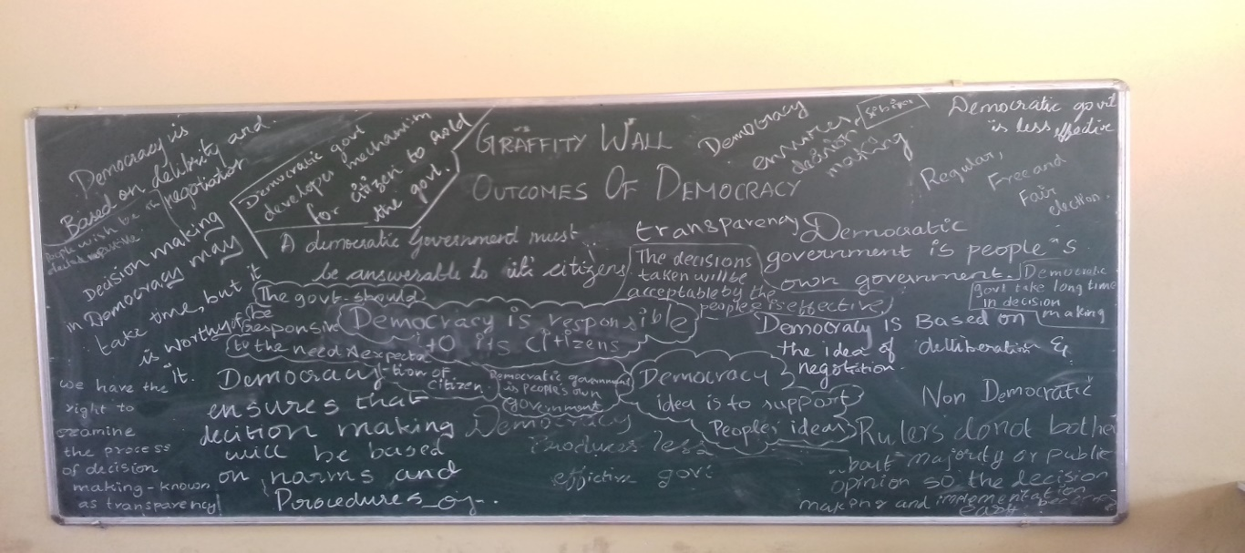

**Lesson plan for Graffiti wall-** <https://theashok-my.sharepoint.com/:w:/r/personal/leni_thealschool_org/_layouts/15/Doc.aspx?sourcedoc=%7BD3CB053C-A2C4-426D-AB83-F17C7E22A78E%7D&file=GRADE%20X_OUTCOMES%20TO%20DEMOCRACY.docx&action=default&mobileredirect=true>

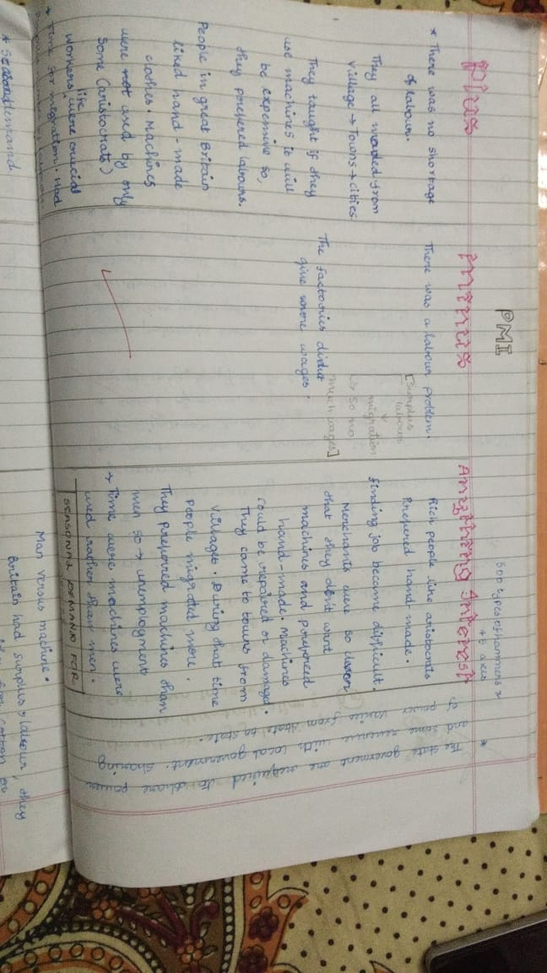**PMI (PLUS MINUS METHOD) -** Students sit in groups and are asked to go through a particular portion in their text. After discussing in groups the concept, they draw three columns in their class work where they write what they have understood in the PLUS column, the concepts that they didn’t understand under difficulties in Minus and if there was anything interesting in the Interesting Column. A group is then asked to write their PMI on the Board. After which, each group is challenged to find solutions or answers to the negatives found which would be discussed. The teacher facilitates the discussion wherein each group finds answers and helps the other group. This fosters learning in a new level as students itself try to find answers to the problems faced by other groups and the teacher plays the role of a facilitator and guide.

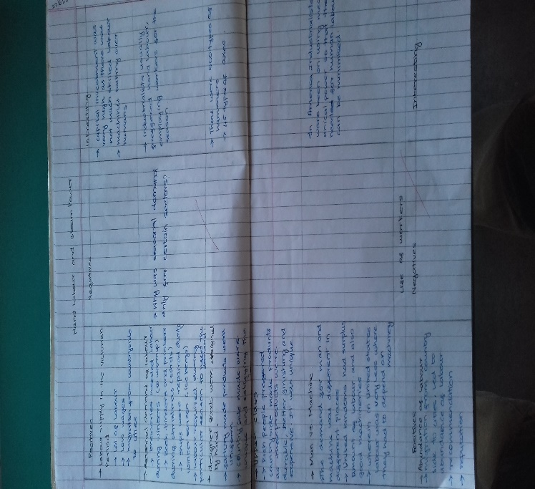

**Lesson plan for PMI-** <https://theashok-my.sharepoint.com/:w:/r/personal/leni_thealschool_org/_layouts/15/Doc.aspx?sourcedoc=%7B22D92BD1-B806-40DD-9C96-C62C5EE61A29%7D&file=X_HISTORY-%20AGE%20OF%20INDUSTRALIZATION.docx&action=default&mobileredirect=true>

1. **Challenges faced**

Personally a mindset change from the conventional process was the hardest as I feared about whether the students would be receptive to the change. This involved reinventing strategies that would interest the child, in-depth research on the topic so that the lesson could be taught in an innovative way. A change from being teacher centric to students centric was the hardest challenge faced.

1. **Resources involved**

Newspapers, Magazines, Internet, Videos,

**EVIDENCE OF OTHER STRATERGIES**

* Photographic evidences

**KWL**

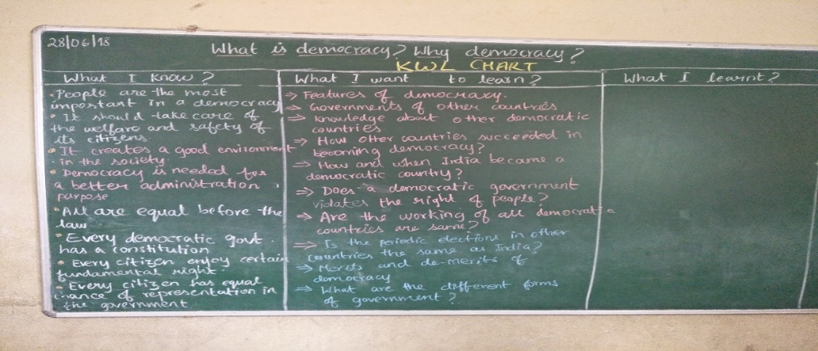

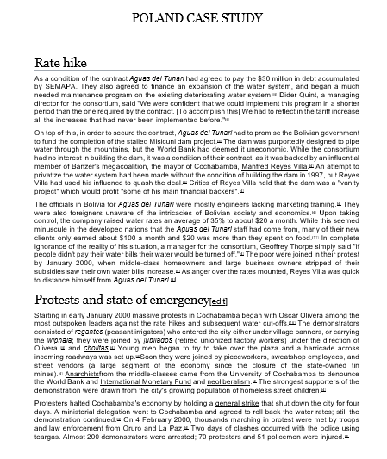**CASE STUDY**

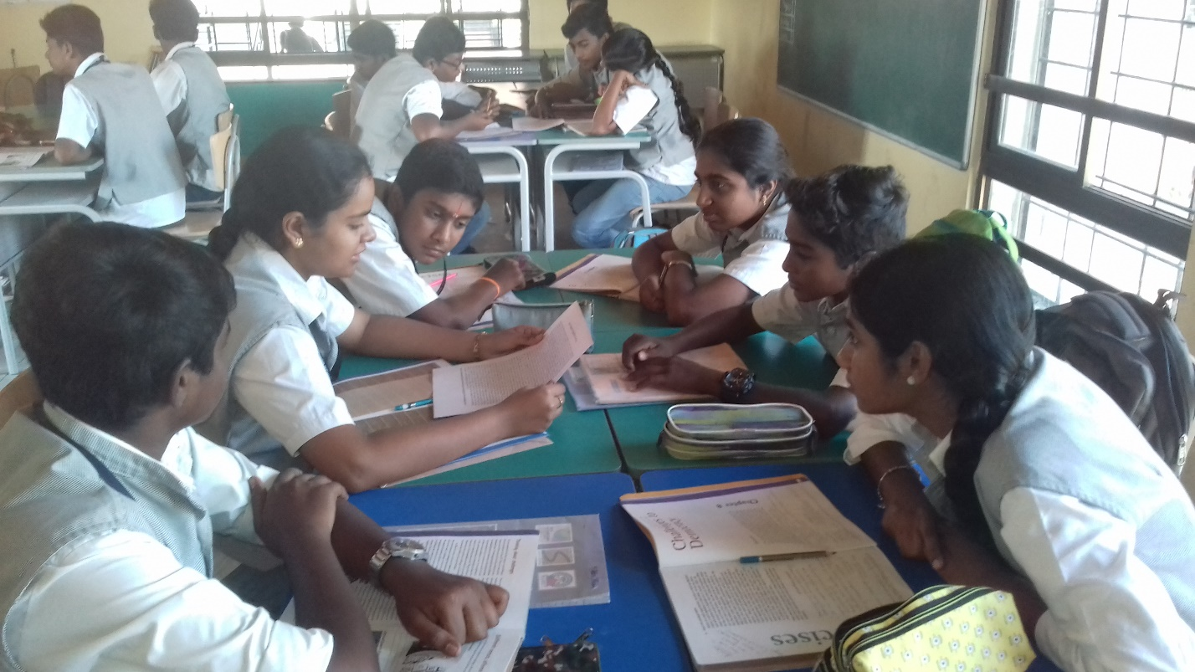

* Lesson plans

1. **KWL-** <https://theashok-my.sharepoint.com/personal/leni_thealschool_org/_layouts/15/Doc.aspx?sourcedoc=%7B2361E1FC-41FE-4C8B-B07D-9A1AE99417C0%7D&file=X_CIVICS_%20DEMOCRACY%20AND%20DIVERSITY.docx&action=default&mobileredirect=true&CT=1542102102134&OR=DocLib>
2. **CASE STUDY-** [**https://theashok-my.sharepoint.com/:w:/r/personal/leni_thealschool_org/_layouts/15/Doc.aspx?sourcedoc=%7BD4C09337-E433-40C5-9F9E-4CB1698C1F3D%7D&file=GRADE%20X-%20CHALLENGES%20TO%20DEMOCRACY.docx&action=default&mobileredirect=true**](https://theashok-my.sharepoint.com/:w:/r/personal/leni_thealschool_org/_layouts/15/Doc.aspx?sourcedoc=%7BD4C09337-E433-40C5-9F9E-4CB1698C1F3D%7D&file=GRADE%20X-%20CHALLENGES%20TO%20DEMOCRACY.docx&action=default&mobileredirect=true)

**BENEFICIARY SATISFACTION**

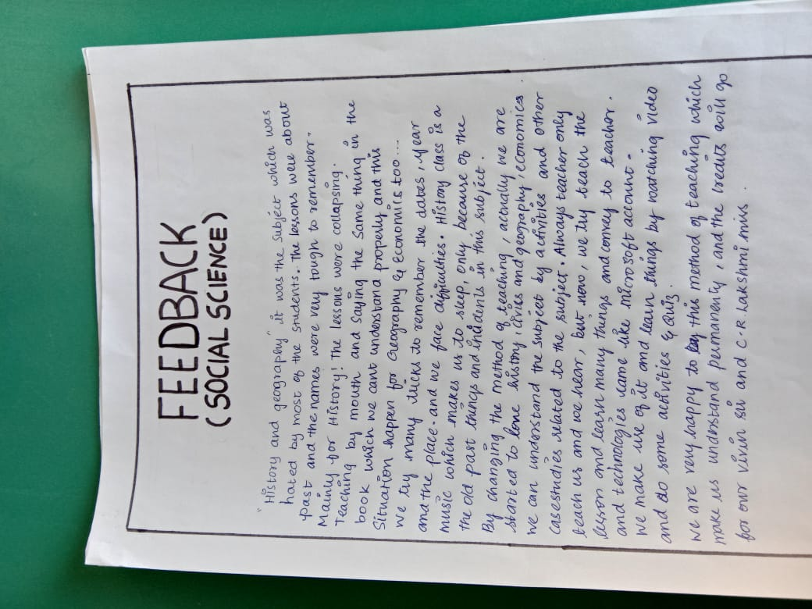Student’s feedback has been enclosed

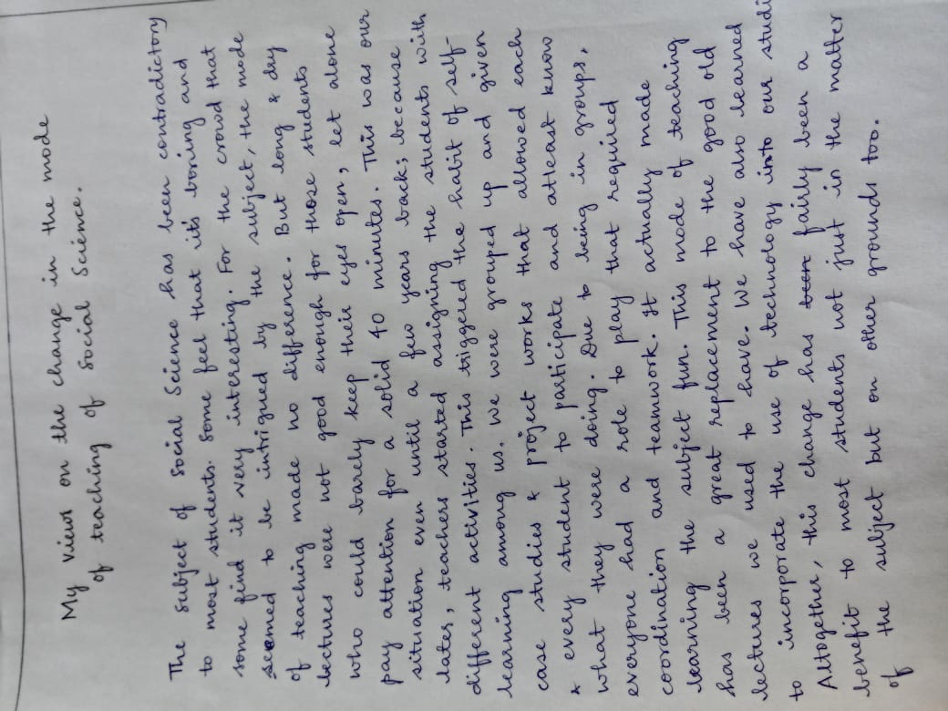

* Changes have also been seen in lesson plans by the teacher as more of graphic organizers and other skills have been promoted have been adopted which has helped in making the learning much easier for the child.

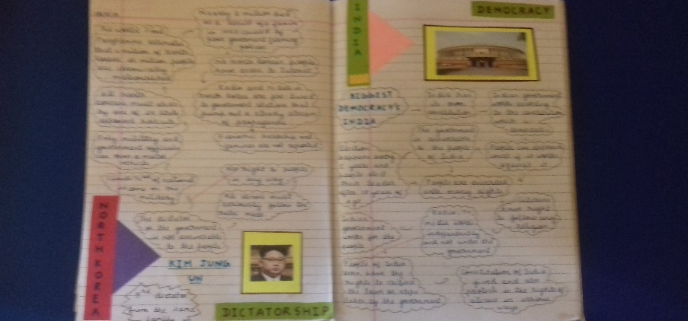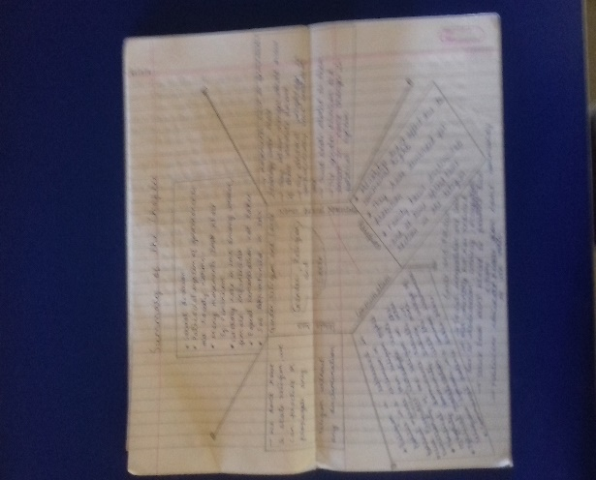

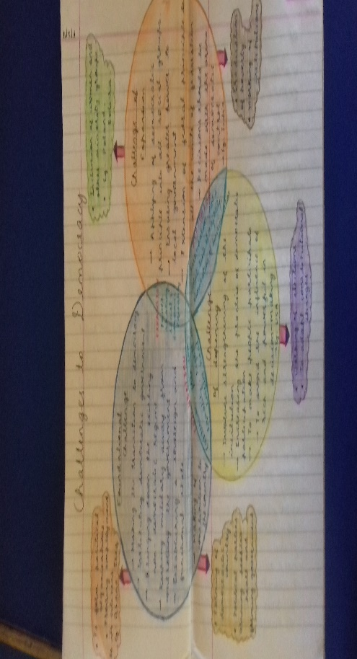

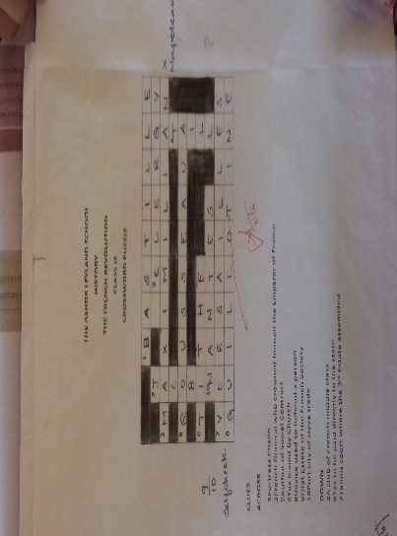

**CONCLUSION**

As we continue to study the human mind, I have found that everyone learns differently. Some people can sit in a lecture hall and just absorb the information from the speaker. Others may have to read the information themselves. Still others may have to actually do the process before they fully understand. This is where active learning comes in.

Children have now tended to be more attentive in the class as they are constantly being engaged in various methods to make them explore, think. Giving them autonomy, ensuring greater involvement and control over their learning and giving them skills to foster lifelong learning in the future. This is how the department has gone for an overhaul that has now ensured that the students who once called it bored and vague have now developed interest towards the same.

A radical shift in marks, interest towards the subject, research based learning have been seen. As a teacher initially it was hard to bring about a change in my teaching methodology, but slowly the change has been made and a lot of focus on researching as a teacher on the subject has improved which in turn has helped me rework my approach towards imparting the lesson to my students.

**GLOSSARY**

1. **Autonomy-** freedom from external control or influence; independence.
2. **Active learning -** means students engage with the material, participate in the class, and collaborate with each other, have them help demonstrate a process, analyze an argument, or apply a concept to a real-world situation.
3. **Teaching methodology** - comprises the principles and methods used by teachers to enable student learning.
4. **Student Centric**- putting students' interests’ first, acknowledging student voice as central to the learning experience.
5. **Graffiti wall –** Writing the key points of the topic on the board.

**KEY WORDS FOR SEARCHING ON IT PLATFORM**

Active Learning strategies in the Ashok Leyland School.

**REFERENCE**

1. <https://teachingcommons.stanford.edu/resources/learning-resources/promoting-active-learning>
2. <http://crlt.umich.edu/active_learning_introduction>





